Chat with Retail Documents(RAG)
Course Name: GEN AI

Institution Name: Medicaps University – Datagami Skill Based Course

Student Name(s) & Enrolment Number(s):
Sr no | Student Name | Enrolment Number
01 | Shubham Kumawat | EN22CS301943
02 | Shivanshu Verma | EN22CS301917
03 | Shivani Vishwakarma | EN22CS301913
04 | Shubh Kapadia | EN22CS301942
05 | Shobha Goswami | EN22CS301922

Group Name: 06D8
Project Number: GAI-41
Industry Mentor Name:
University Mentor Name: Prof. Divya Kumawat
Academic Year: 2025- 2026

1. Introduction
1.1 Scope of the Document
This document provides a detailed low-level design of the Retail Document Intelligence System, which is built using a Retrieval-Augmented Generation (RAG) architecture. The system enables users to upload retail-related documents such as PDF reports, manuals, and business insights, and interact with them through natural language queries.
The scope includes:
- Backend architecture using FastAPI
- Document processing pipeline (PDF → chunks → embeddings → vector database)
- Query processing using semantic search and LLM
- Frontend interaction layer (React-based UI)
- API design and data flow
This document focuses strictly on the implemented system and excludes unrelated enterprise-scale features like distributed systems or microservices.

1.2 Intended Audience
- Developers and maintainers
- Academic evaluators
- System designers

1.3 System Overview
The Retail Document Intelligence System is an AI-powered application that allows users to:
- Upload retail-related PDF documents
- Automatically process and index documents
- Ask natural language questions
- Receive context-aware answers generated by an LLM

The system combines:
- Vector Database (FAISS) → retrieves relevant document chunks
- LLM (Gemini) → generates final answer
This ensures:
- Accurate answers grounded in documents
- Reduced hallucination
- Domain-specific intelligence

2. System Design
2.1 Application Design
The application follows a client-server architecture:
- Frontend (React + TypeScript)
- Upload documents
- Display document list
- Chat interface for queries
- Shows answers
- Backend (FastAPI)
- Handles API requests
- Processes PDFs
- Creates embeddings
- Stores vectors
- Performs retrieval
- Calls LLM
- AI Layer
- Embeddings: all-MiniLM-L6-v2
- Vector DB: FAISS
- LLM: Gemini (gemini-2.5-flash)

2.2 Process Flow
End-to-End Workflow
- Step 1: Document Upload
- User uploads PDF via frontend

- Frontend sends POST request /upload
- Backend saves file locally
- Step 2: Document Processing
- PDF is loaded using PyPDFLoader
- Text is extracted page-wise
- Text is split into chunks (1000 chars, 200 overlap)
- Step 3: Embedding Creation
- Each chunk is converted into vector embeddings
- Using sentence-transformers model
- Step 4: Vector Storage
- Embeddings stored in FAISS
- Enables fast similarity search
- Step 5: User Query
- User asks question via UI
- Frontend sends POST /ask
- Step 6: Retrieval
- Query converted to embedding
- FAISS retrieves top-K relevant chunks
- Context is constructed
h. Step 7: LLM Processing
- Context + query sent to Gemini
- LLM generates answer
i. Step 8: Response
- Backend sends answer to frontend
- UI displays response

2.3 Information Flow
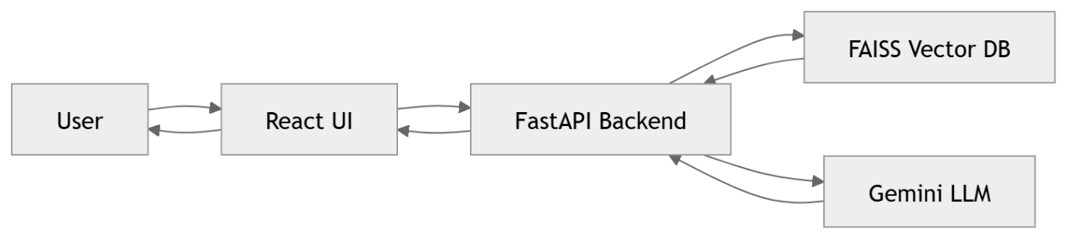
Information Flow diagram

2.4 UML Diagram
a. Class Diagram
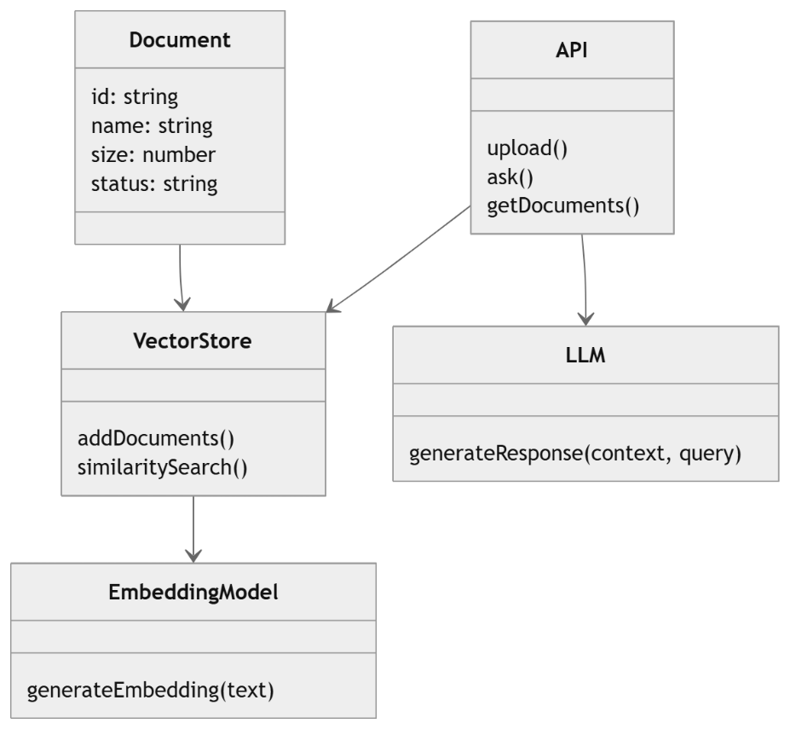
Class Diagram

b. Sequence Diagram
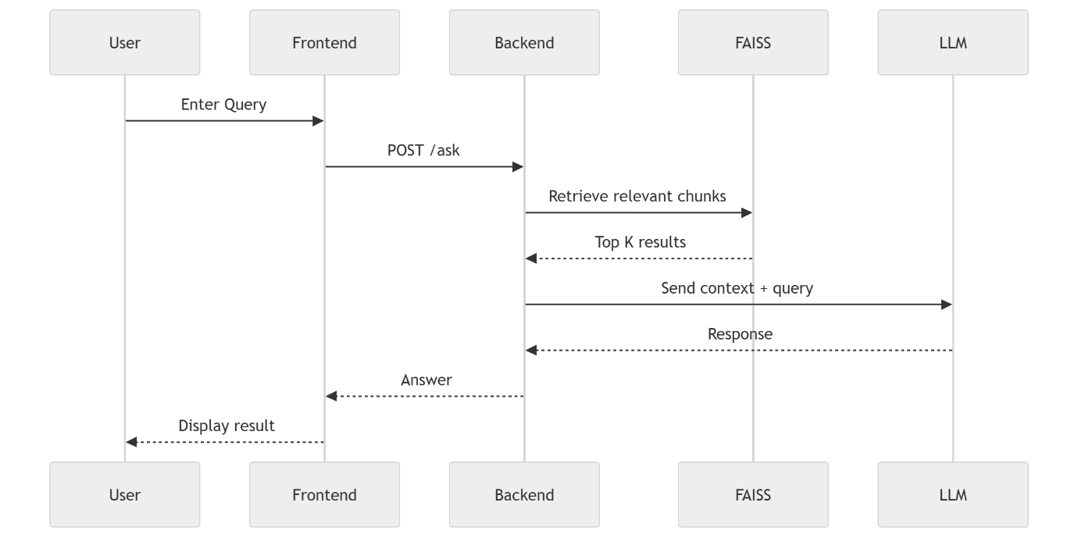
Sequence Diagram

c. Architecture Diagram
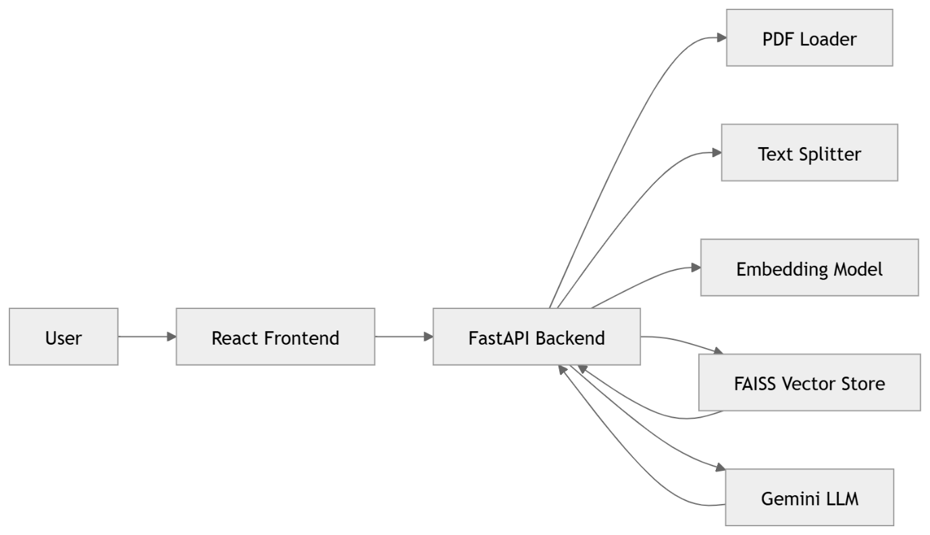
Architecture Diagram
2.5 Components Design
- Document Loader → Extracts text
- Text Splitter → Creates chunks
- Embedding Model → Converts text to vectors
- Vector Store → Stores embeddings
- Retriever → Fetches relevant chunks
- LLM → Generates final response

2.6 Key Design Considerations
- Fast retrieval using FAISS
- Context-based answering to reduce hallucination
- Modular design for scalability
- Lightweight models for local performance

